 Microsoft Power Automate Desktop

Lab 05: Call REST APIs from Power Automate Desktop

Hands-on lab step-by-step

August 2024

Microsoft Power Automate Desktop – Advanced Workshop

Contents

Microsoft Power Automate Desktop 1

Goals for this lab 1

Prerequisites 1

Exercise: Extract purchased items from PDF invoices 2

Terms of Use 7

# Microsoft Power Automate Desktop

This lab is subject to the Terms of Use found at the end of this document.

## Goals for this lab

|  |  |
| --- | --- |
| After this lab you will be able to:   * Perform an HTTP request to a public REST API and retrieve its response in a JSON format * Use the results from your API calls to manipulate data in an Excel worksheet | The time to complete  this lab is [30] minutes. |

## Prerequisites

The labs have been designed so if you have access to a Microsoft Power Automate Desktop trial, you can get started from most labs without having to complete the previous module to be able to move forward. However, for the best experience that shows the features and functionality that is possible within the product, it is recommended you have completed specific modules before starting some of the labs.

For Lab 05: Call REST APIs from Power Automate Desktop, you need:

* A computer with internet access.
* The application Power Automate Desktop installed in your computer. If you don’t have the application installed, please download it here: <https://go.microsoft.com/fwlink/?linkid=2102613>
* Be able to log into your corporate tenant.

## Exercise: Extract purchased items from PDF invoices

### Task 1: Download sample Excel worksheet from the repository

1. Navigate to <https://github.com/mcoloradodevs/PowerAutomateDesktopTraining/blob/main/All%20Invoiced%20Products.xlsx> and download the Excel file named **‘All Invoiced Products.xlsx’**

### Task 2: Log into Power Automate Desktop

1. Open the **Power Automate Desktop** app on your computer
2. Log into the application using your corporate account
3. If you don’t have a Power Automate Premium license, start a trial by clicking on the **Go Premium** button at the top right corner of the application



### Task 3: Perform a test call to a public API

1. Make sure you create your automations in your own **Personal Development environment**. If you don’t have one, follow the steps here: [Get your developer environment - Power Apps | Microsoft Learn](https://learn.microsoft.com/en-us/power-apps/maker/maker-create-environment#create-your-own-developer-type-environment)

**Special note for Walmart 💡:** Power Platform administrators have blocked the option to create Personal Development Environments in the tenant. For this training, you can use the default environment titled **Walmart Store Inc.**, but in production scenarios, it is a best practice to develop the automations on a dedicated environment. Contact your team leader for more information about your dedicated environment.

1. Click on **+ New Flow** and create a flow named Lab 05: Call REST APIs from PAD. Add your name at the end of the flow to recognize it easily.
2. Once on the flow designer, navigate to the **Variables** panel to the right of the screen and create a new **Input** variable
3. Configure the new variable as shown:

* Variable name: CurrencyConverterAPIKey
* Data type: Text
* Default value: fca_live_oEq68nP58lUQSP5an3CVLum1Exm5zuCxpmhFEjij
* External name: CurrencyConverterAPIKey
* Description: API Key for the Currency Converter API
* Mark as sensitive: Yes

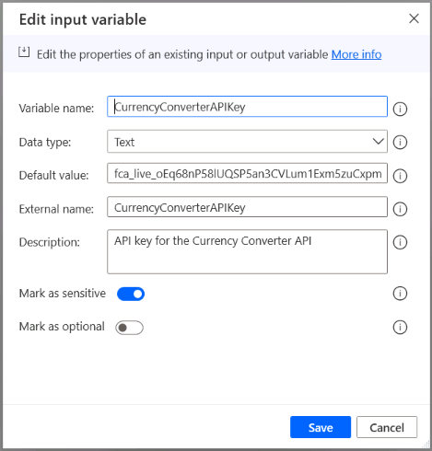

1. Add the action **Set variable**  to your flow and create a new variable named URICurrencyConverterAPI. On the value, write the expression: <http://api.freecurrencyapi.com/v1/latest?base_currency=USD&currencies=EUR>

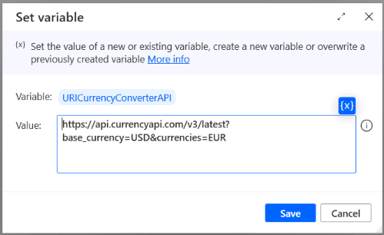

1. Add the action **Invoke web service** to your flow and configure it as shown:

* **URL:** %URICurrencyConverterAPI%
* **Method:** Get
* **Accept:** application/json
* **Content type:** Application/json
* **Custom headers:** apikey:%CurrencyConverterAPIKey%
* **Save response:** Get text into variable (for web pages)
* **Variables produced:** Disable the variable WebServiceResponseHeaders and rename the variable WebServiceResponseText to CurrencyConverterAPIResponse

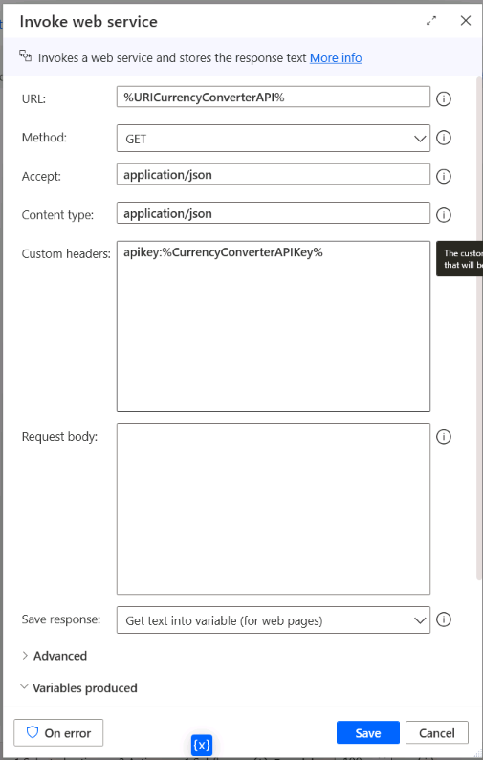

1. Add the action **Convert JSON to custom object** and configure it as shown below:

* **JSON:** %CurrencyConverterAPIResponse%
* **Variables produced:** CurrencyConverterObject

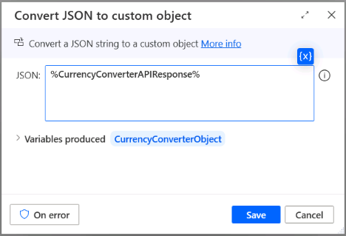

1. Create a new variable named USDToEURExchangeRate and assign the value obtained from the API call as seen below:

* Variable: USDtoEURExchangeRate
* Value: %CurrencyConverterObject[‘data’][‘EUR’][‘value’]%

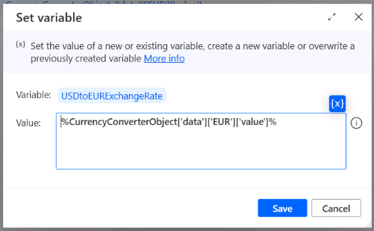

1. Run your flow and inspect the value on the USDtoEURExchangeRate variable, which should be the exchange rate obtained from the Currency Converter API

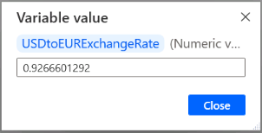

### Task 4: Challenge – Convert all product Unit Prices from USD to EUR

We have now learnt how to call an API with basic authentication from Power Automate Desktop. In previous exercises, we have also seen how to import Excel table data into Data table variables and add new columns into these tables.

Your challenge now is to put this knowledge into test by attempting to convert all prices in the column **Unit price** on the file **All Invoiced Products.xlsx** from USD to EUR and add a new column to the file with the result. Good luck!

## Terms of Use

By using this document, in whole or in part, you agree to the following terms:

### **Notice**

Information and views expressed in this document, including (without limitation) URL and other Internet Web site references, may change without notice. Examples depicted herein, if any, are provided for illustration only and are fictitious. No real association or connection is intended or should be inferred. This document does not provide you with any legal rights to any intellectual property in any Microsoft product.

### **Use Limitations**

Copying or reproduction, in whole or in part, of this document to any other server or location for further reproduction or redistribution is expressly prohibited. Microsoft provides you with this document for purposes of obtaining your suggestions, comments, input, ideas, or know-how, in any form, ("Feedback") and to provide you with a learning experience. You may use this document only to evaluate its content and provide feedback to Microsoft. You may not use this document for any other purpose. You may not modify, copy, distribute, transmit, display, perform, reproduce, publish, license, create derivative works from, transfer, or sell this document or any portion thereof. You may copy and use this document for your internal, reference purposes only.

### **Feedback**

If you give Microsoft any Feedback about this document or the subject matter herein (including, without limitation, any technology, features, functionality, and/or concepts), you give to Microsoft, without charge, the right to use, share, and freely commercialize Feedback in any way and for any purpose. You also give third parties, without charge, the right to use, or interface with, any Microsoft products or services that include the Feedback. You represent and warrant that you own or otherwise control all rights to such Feedback and that no such Feedback is subject to any third-party rights.

### **DISCLAIMERS**

CERTAIN SOFTWARE, TECHNOLOGY, PRODUCTS, FEATURES, AND FUNCTIONALITY (COLLECTIVELY "CONCEPTS"),

INCLUDING POTENTIAL NEW CONCEPTS, REFERENCED IN THIS DOCUMENT ARE IN A SIMULATED ENVIRONMENT

WITHOUT COMPLEX SET-UP OR INSTALLATION AND ARE INTENDED FOR FEEDBACK AND TRAINING PURPOSES

ONLY. THE CONCEPTS REPRESENTED IN THIS DOCUMENT MAY NOT REPRESENT FULL FEATURE CONCEPTS AND MAY

NOT WORK THE WAY A FINAL VERSION MAY WORK. MICROSOFT ALSO MAY NOT RELEASE A FINAL VERSION OF SUCH

CONCEPTS. YOUR EXPERIENCE WITH USING SUCH CONCEPTS IN A PHYSICAL ENVIRONMENT MAY ALSO BE DIFFERENT.

THIS DOCUMENT, AND THE CONCEPTS AND TRAINING PROVIDED HEREIN, IS PROVIDED “AS IS”, WITHOUT WARRANTY

OF ANY KIND, WHETHER EXPRESS, IMPLIED, OR STATUTORY, INCLUDING (WITHOUT LIMITATION) THE WARRANTIES OF

MERCHANTABILITY, FITNESS FOR A PARTICULAR PURPOSE, TITLE, AND NONINFRINGEMENT. MICROSOFT DOES NOT

MAKE ANY ASSURANCES OR REPRESENTATIONS WITH REGARD TO THE ACCURACY OF THE RESULTS, THE OUTPUT THAT DERIVES FROM USE OF THIS DOCUMENT OR THE CONCEPTS, OR THE SUITABILITY OF THE CONCEPTS OR INFORMATION CONTAINED IN THIS DOCUMENT FOR ANY PURPOSE.